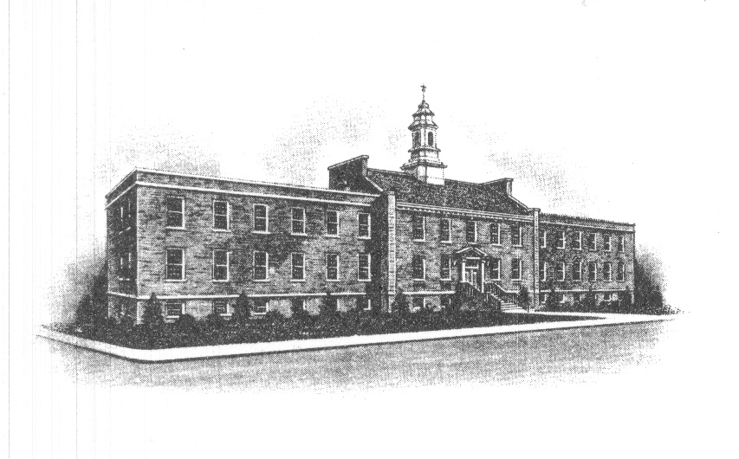
The Borough of Sayreville
Sayreville Board of Adjustment
167 Main Street
Sayreville, NJ 08872
(732) 390-7077 - Phone
(732) 390-7458 - Fax

ZONING BOARD OF ADJUSTMENT

MARCH 25, 2020 MEETING CANCELATION NOTICE

Please take notice that the Zoning Board of Adjustment in the Borough of Sayreville, N.J. has canceled its Wednesday, March 25, 2020 meeting. The following matters which were to be heard on March 25, 2020, are hereby adjourned to Wednesday, April 22, 2020 at 7:30 PM, without the need for further notice:

Case No. | Applicant | Location | Application
20-02  20-05  20-06  20-07  19-12 | BKD, LLC  Denise McLaughlin  Andrew Barsky  Thomas Pizzillo  Mary Aileen, LLC | 1979 Highway 35 No.  South Amboy, NJ  Block 426, Lot(s)  - & 2.01  19 Lavern Street  Block 114, Lot 13.01  211 MacArthur Ave.  Block 173, Lot 2.01  23 Rota Drive  Block 447.07 Lot 15  Jernee Mill Road | Use Variance/Site Plan  Bulk Variance/Pool  Use Variance/Bulk Variance  Bulk Variance/Garage  Use Variance/Trailer Storage

This meeting is being canceled as a public health and safety precaution due to the spread of the COVID-19 Corona Virus. The Board anticipates resuming normal meeting schedule as of the April 22, 2020 meeting; however, due to the uncertainty of this situation that meeting could be also canceled, and if it is another notice will be posted.

Joan M. Kemble
Secretary
Zoning Board of Adjustment

